⁸

Nov 07, 21

Heard her on phone explaining it will be tough sending money. She will talk to aerij. I told her I have 350. She can take 300. Not even a thank you.

Nov 08

Found a pair of my sock in the toilet paper rack. She said, is this the goal of my life now to move your things. I caulked so much area in the living room and kitchen but she never saw that. I have to improve myself. Ill keep reminding me.

Nov 09: I think I am irritated of her. I know I shouldn’t be. I keep reminding myself to be better, to do better. She came from work, we talked about the county officer saying he can't do anything about the easement trash thing. I explained to her what easement is and she OfCourse negated. Even the smallest things are so hard to talk to with her. She comes from work. Goes upstairs, usually stays there till she sleeps, always saying she is tired. Improve yourself.

Nov 10, 2020

It was a relatively decent day till she returned from gym. Ice play slipped and we thought he might have hurt his front right limb. I said we talked about a rug but never got any. She took a huge pfffft sigh. It ticked me off I said what was that about. She replied with a huge breath. “I don’t want rug everywhere where he goes “ I said he mainly stays in this area in the living room. Said. Do what you want.

I am finding it harder and harder to talk to her about even the littlest things. Nkw soon as she said that. She is back upstairs. Tired from her yoga class. I get she is tired. But she is tired everyday. She is annoyed all the time.

But I must focus on improving myself.

Nov 11, 21

Had sex after a few weeks. I went up and saw her in bed. It doesn’t feel the same. Like something is off. I feel deceived. She showed a picture of her legs that she liked. I need to be stop being overly critical. I said, after you lose more fat it will look even better. I didn’t think I was being critical. But I am sure it does not come off nice. Sex now is becoming about her. She seems obsessed with herself. Its hard to explain how I feel that. She acts like a goddess of beauty and I keep failing to see it. She has gained too much weight. And she is embracing it as normal. Anything I say is fat shaming. This was one of the few things we always agreed on growing up. Maybe sex will get better. I also feel there might be sokething going on with austin. Just my suspicion I am sure.

Thought: am I living in some moments in the past? How do I live in the moment then?

Nov 16

Do I preceive myself as someone else than myself due to my childhood trauma? My coke sides.

Nov 18

I am angry. Very much so. Feeling sick and tired of her attitude. Her disregard of my respect. Asked her what to get for dinner. She said her mind is not working. I said lets do something different. She said what I was thinking. Shamshiri. I asked yea. Fucking shit I am mad. She wemt off about hiw she wants to experience it without letting me say anything. She meant dining in sometime. I said sure, v can do that but I mean for now and then she is like I can go anywhere but there. I cant go pick it up. I said I didn’t ask u to go pick it up. Amd then in her extremely shitty way, she is like get what you want for yourself. I ate something. Writing this even I think what is so wrong with what she said. I guess it’s the whole pileup of things. How she makes me feel about myself. Had sex today in evening when she walked down naked. Its just not the same. I am starting to pull far far away from her. Maybe from myself. From everyone.

Its like she will show even simple respect only when all her past present needs are fully met in her mind. How can that ever happen. If someones criteria of happiness towards themselves or others is so complicated.

Nov 21

Drove me to Adnan bhai’s house. Gave me a blow job on the way there. Brought back so many memories. Felt very good. Not just the bj.

Nov 25

Bad day in general started with saema. Then we fought

Nov 26

Had a realization that I cannot continue thinking or acting in a way that I am doing her a favor by trying to better things. I should try to do better because it is what should be done.

Maybe I should sit her down and talk about her issues with me.

Going to echo for above n beyond after a long time. She really wanted to. But got upset when I confirmed its today and nit tomorrow (Saturdabeyot 5:18pm. Said its her second day of periods and cancelled plans for this. Didn’t make much sense. Confirmed plans with her around 6,7. She’s getting ready. I hope it’s a good night for us.

Dec 08

Today was the 2nd day back at work. I was so tired. Headache. Hungry. She defrosted the 2 kababs I had marinated. Could not bother to fry them up. Went to gym and texted this.

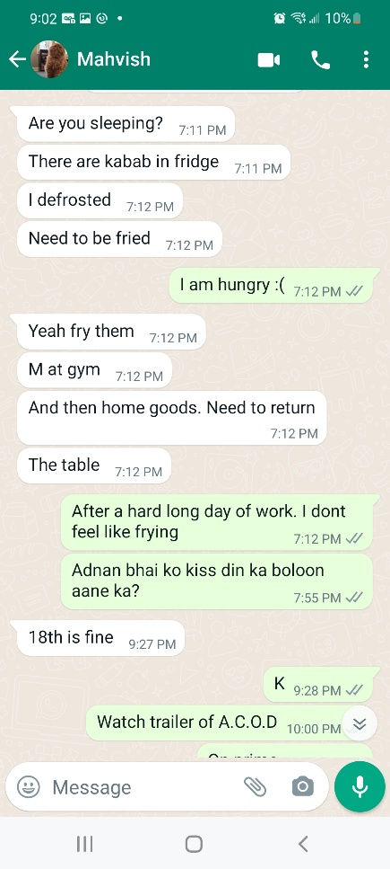

As tired as I was. I got my own food ready. She cones back and says why didn’t you fry the meat for me. I have made food everyday. Almost everyday as long as is here. But this self involved narcissist cannot do anything for me for even 1 day.

Dec 09

I don’t know how it always gets back to the same point. Its like going in circles. I remember how she will always find the worst in the happiest situations. This time, it was about my yearly bonus. I made the mistake of telling her how much pay hike and bonus I am getting. She was happy at first. I even told her she wont have to contribute to the yard work expense. Couple days in. She said and just jokingly. Cake. I want a cake. Like in the fun way she says things sometimes. I said let me get the bonus first. I am very low on cash. Paid 2000 to orlando. Home appraisal fee 500 something. All the bills. Credit card bills. I had about 150. Whereas she soent every single dime she made shopping. Sure she got me some sweaters from banana republic too. However I didn’t complain or comment on her extreme spending.

2 days ago she texted me if I want to go to the basketball game. Follwing is the conversation after I said what I said below. We went to her work basketball thing last year. She spent the entire time chatting with her coworker. I had no ides who is playing. I just don’t care about basketball. But I still said sure.

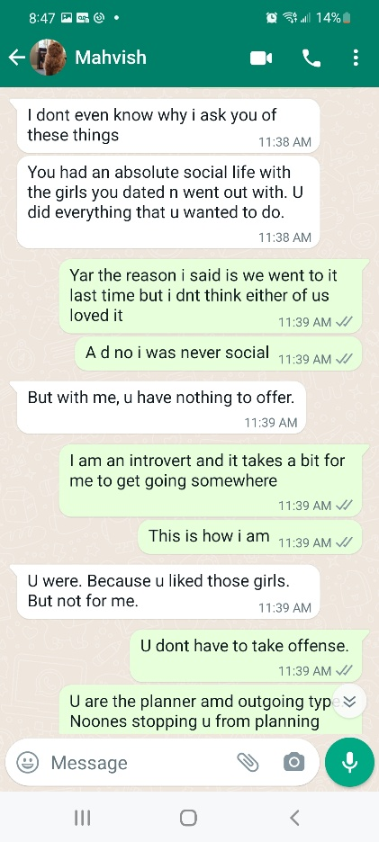

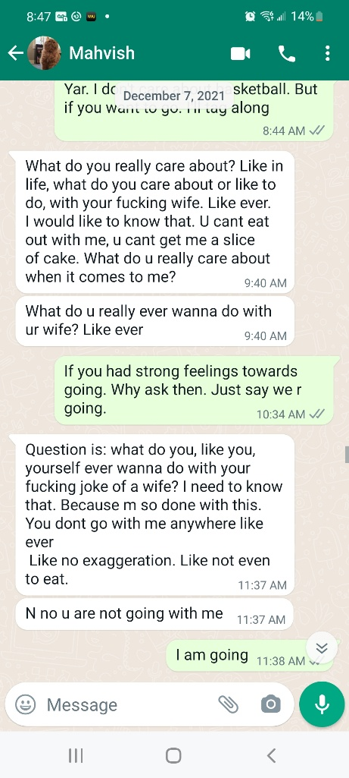

She makes the entire house environment shitty. I hate this. I hate this more than anything. This is exactly how livimg in my dads house was. And the more messed uo thing is that she goes back n forth on how she feels. Like 2 days she kept this crap up. Today in the day she was ok chat below.

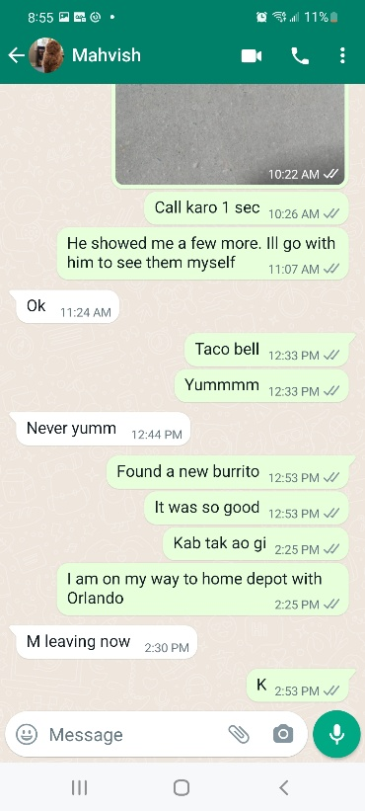

Amd soon as she is back. She is a bitch. Tried talking to her but she just rudely jerks it off.

She went up to sleep so rudely because I had the tv on on vol 4 with subtitles. That was fucking loud to her. She left 2 bites of a large cheese slice. I ate it. Fuck me for that. She comes down and asks and when I say I ate it. She goes. Why. It was not yours. After paying my ass off for food bills mortgage. Those 2 bites werent mine. I asked her why are being so rude. She has the audacity to say “go figure” somehow it felt worse than a fuck off.

What am I doing. And why and why for her.